Team Members:

Bipin Singh (Leader)

Bibek Kr Sah

Shubham Sharma

Pranav Sharma

API Testing

This document consists the Screenshots of testing of the Rest API of eMart

Tool Used: Postman

Tester: Bipin Singh

Getting product of a specific Category

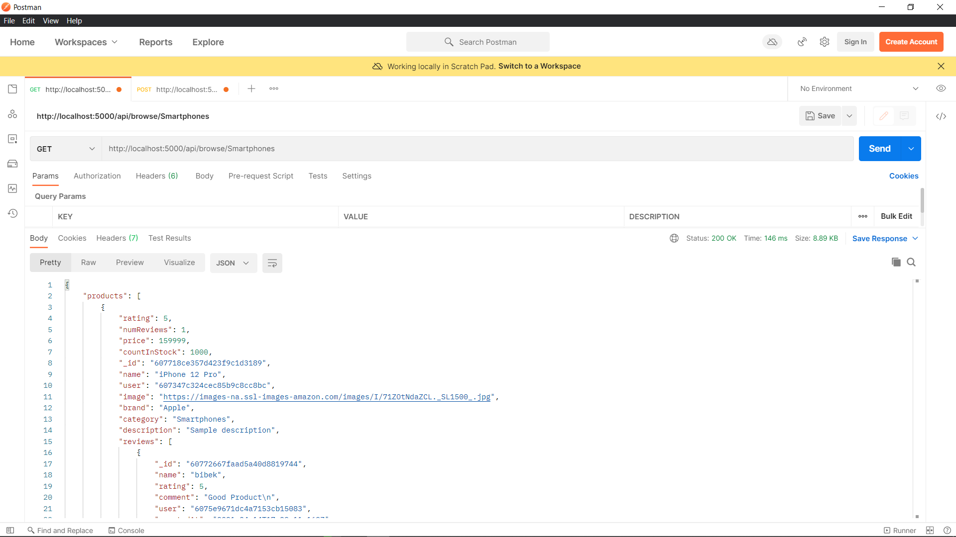

Getting top products

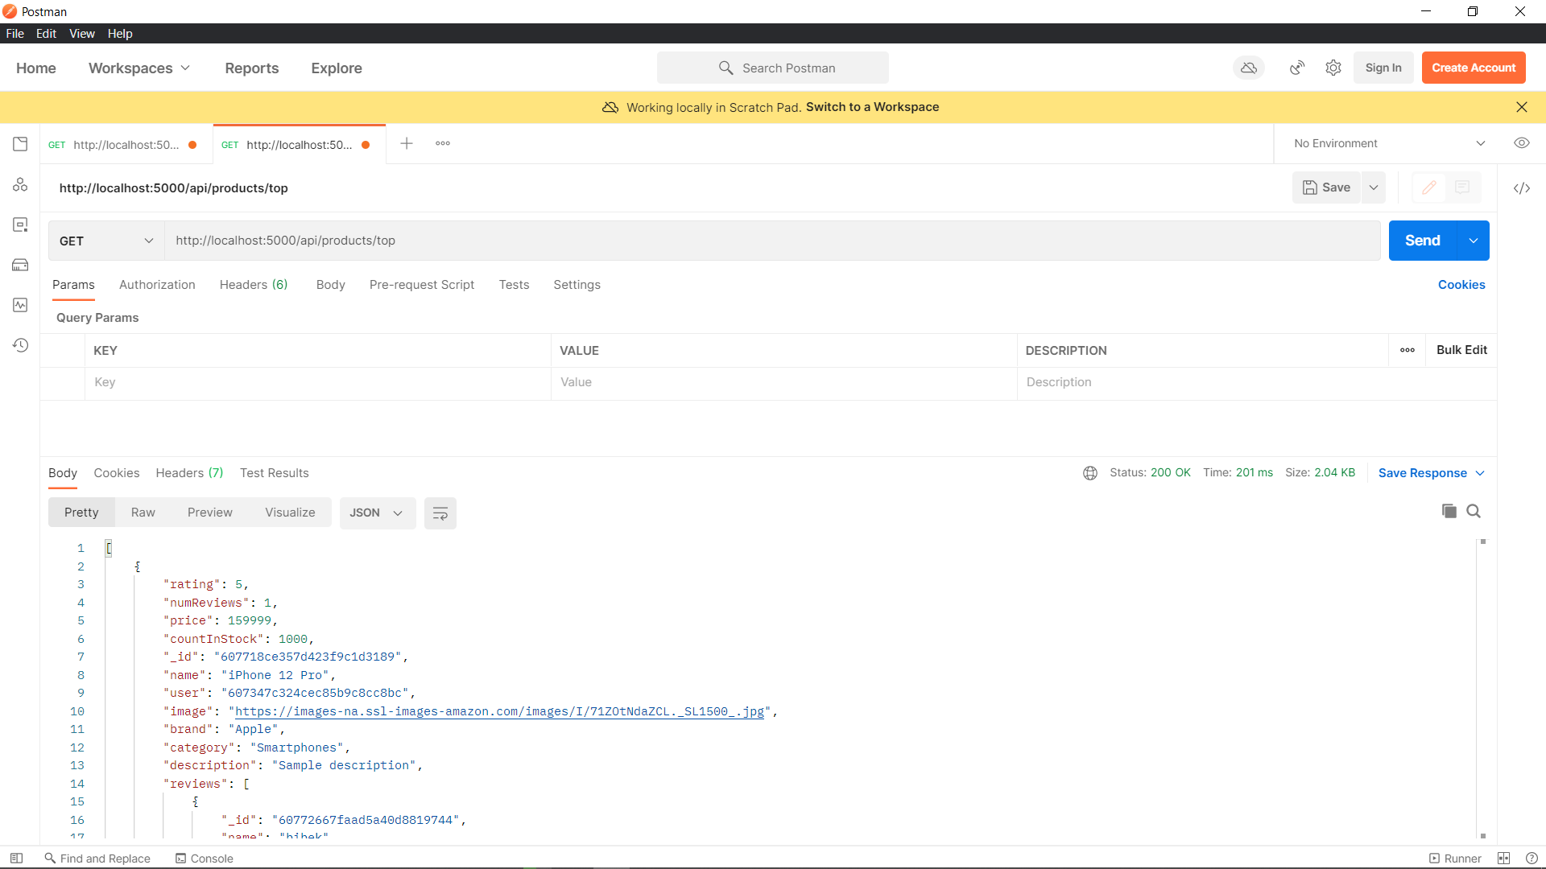

Login User

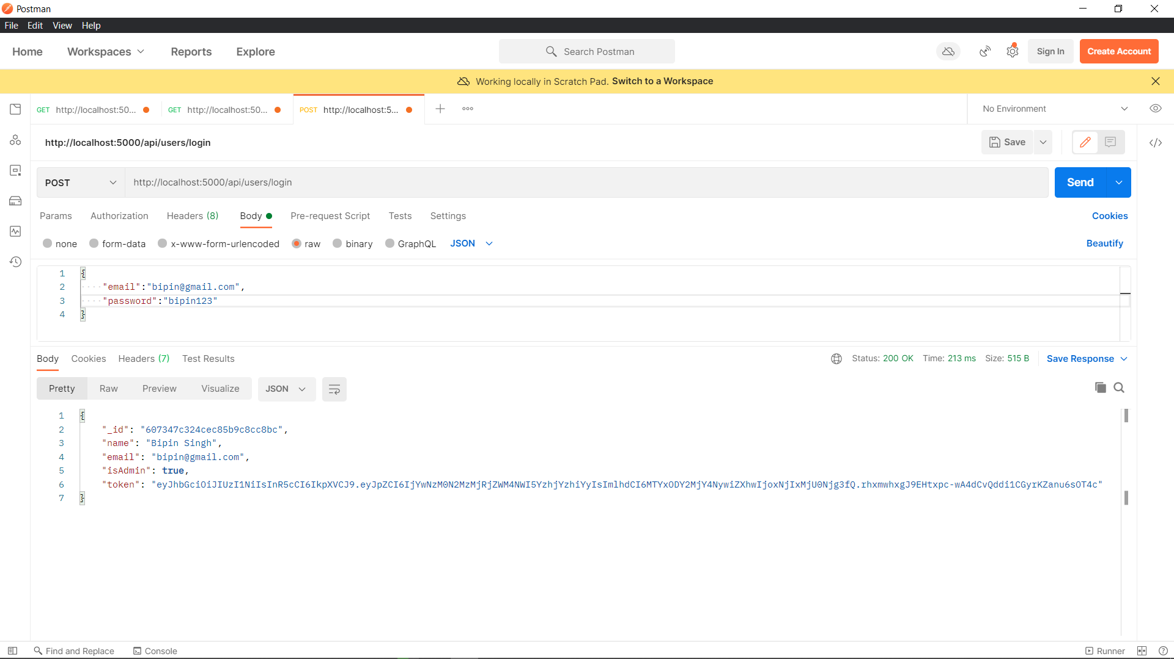

Registering New User

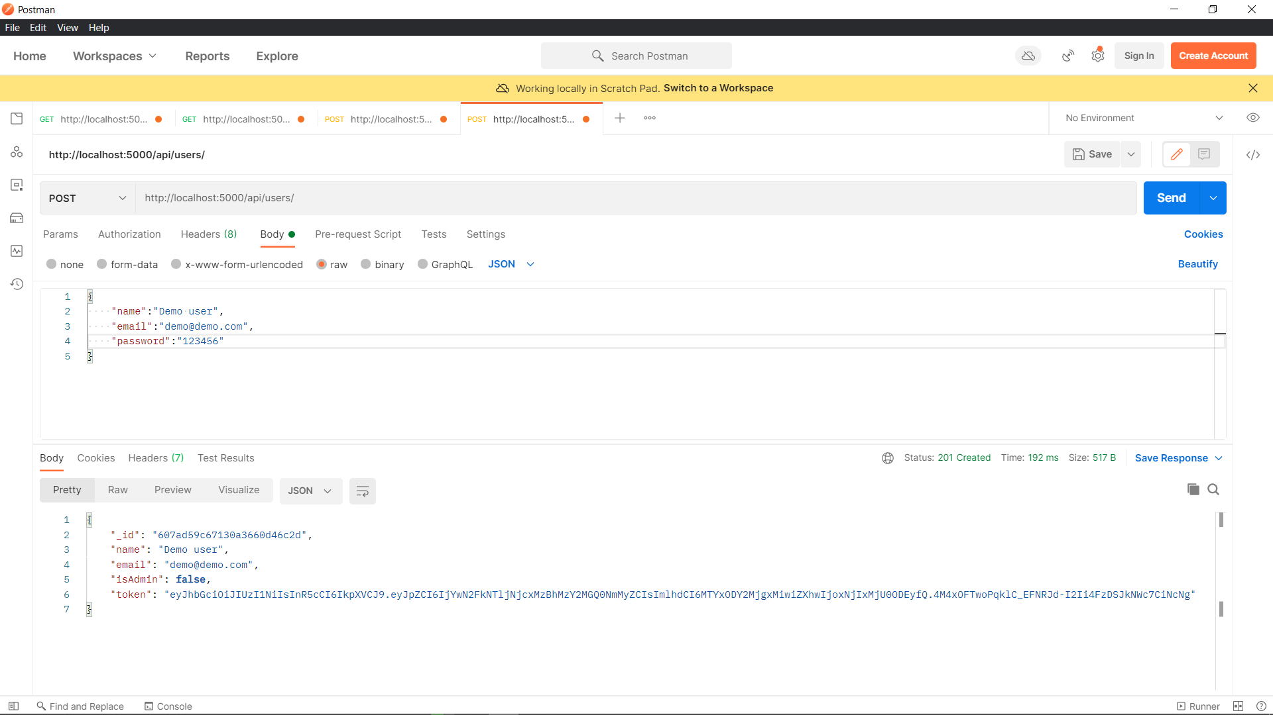

Gettings orders detail

